**Spring Boot**

**Introduction of Spring boot :**

It is a spring framework which we are using for developing enterprise application,

Spring-boot makes it easy to create Stand-Alone ,production grade ,Spring Based Application that you can “just run”

**What is Spring:**

* Application Framework
* Programming and configuration model.
* Infrastructure Support.

**Problem With Spring:**

* Huge Framework.
* Multiple Setup Steps.
* Multiple Configuration Steps.
* Multiple Build and Setup steps.

**Enter Spring Boot:**

* Opinionated.
* Convention over Configuration
* Stand Alone
* Production Ready.

**Required Tool**

* JDK8(oracle site)
* STS(spring io)

Steps to Create Spring Boot Project

* Create Maven Project
* Add Pom .xml

Spring Starter parent

<parent>

<groupId>org.springframework.boot</groupId>

<artifactId>spring-boot-starter-parent</artifactId>

<version>2.1.6.RELEASE</version>

<parent>

<dependencies>

<dependency>

<groupId>org.springframework.boot</groupId>

<artifactId>spring-boot-starter-web</artifactId>

</dependency>

</dependencies>

Spring Statrter Web Dependency

Update Java version in property tag <property>

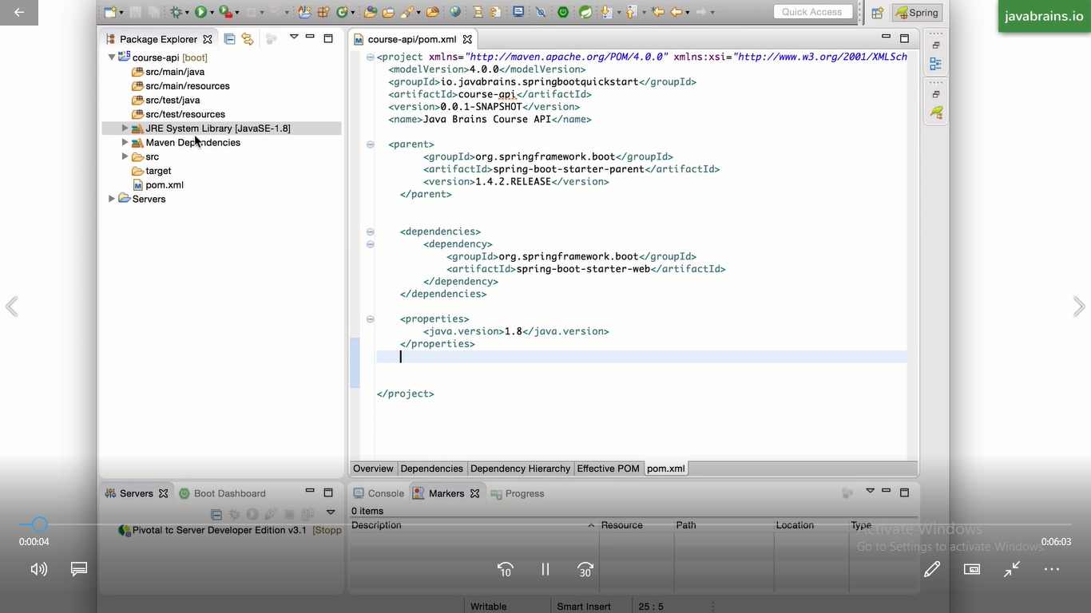

**Note:**

<parent> It is a configuration and provide bunch of dependeny with copaitible to each other t we do not maintain this all version compatible it is handling by itself.it is instruct to maven which version and compatible jars it should download only we have to maintain parent jar version.

.what jars to pool and which version to pool.it is providing preset list by itself.

**Why tomcat server is embedded ? :**

1.Convinence

2.Servlet Container config is now application config.

3.Standalone application.

4.Usefull for microservices architecture.

**Starting Spring Boot:**

1.SpringApplication.run(App.Class,args);

* Setup Default Configuration.
* Start Spring Application Context.
* Performs Class path Scan.(Scan @ marker and perform that according to @)
* Starts Tomcat Server.

**Let’s Add a controller:**

* A Java Class.
* A Java Class Marked With Annotation.
* Has Info About
* What URL Access Triger It.
* What Method to run When Accesses.

**Note: The @Requestmappng only map get mehod by default . to map to other HTTP Methods ,you will have to specify it in the annotation.**

**. Here it is a controller class which returning list of topic.**

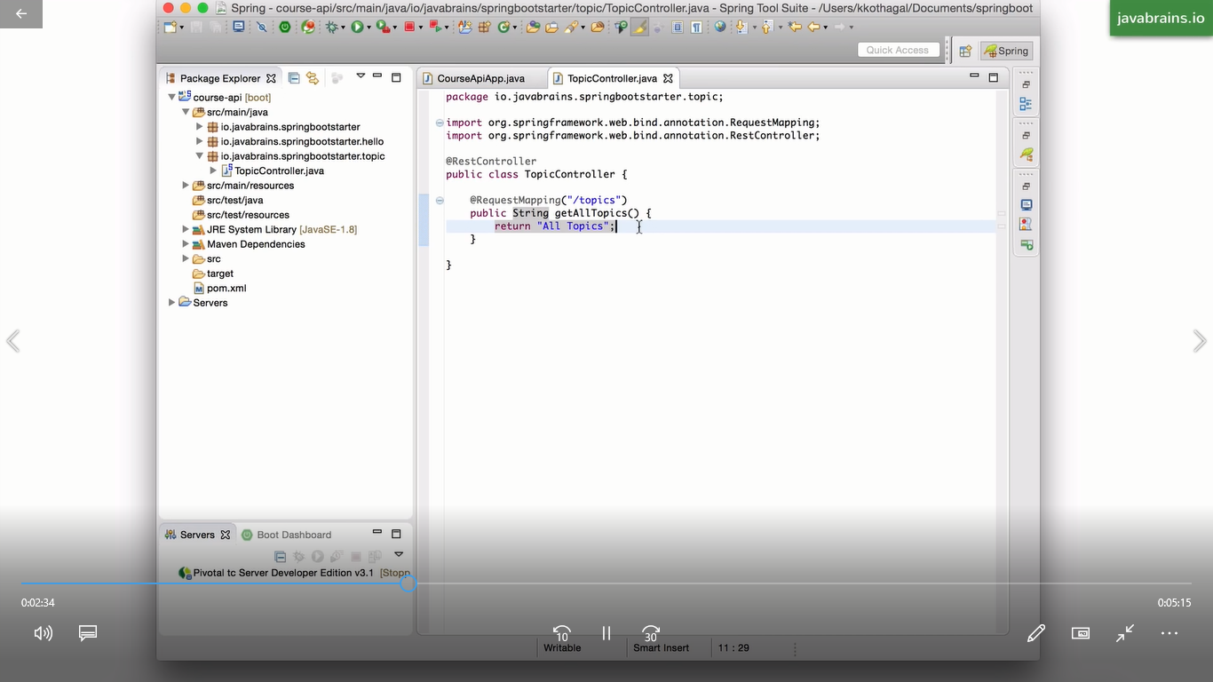

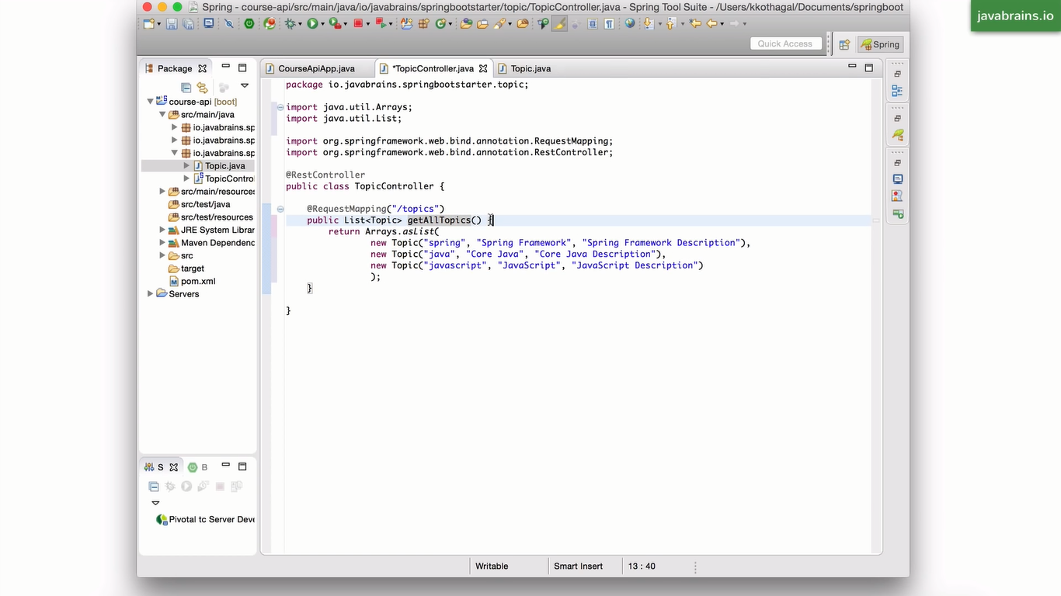

**Getting list of topic by hardcoding list in cotroller class below is the json response for this which is giving automatically by @RestController Annotation.**

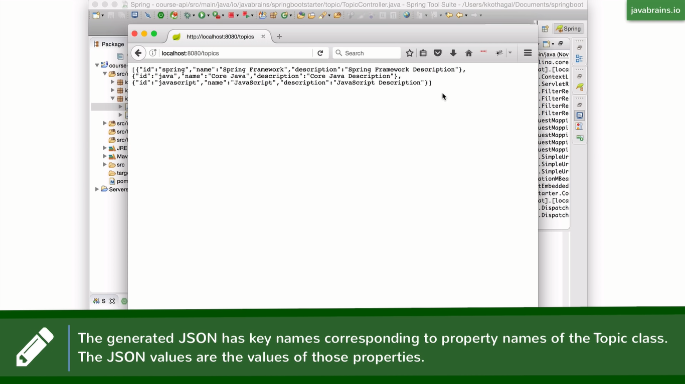

2.Here it is a model class or we can say pojo class which defining the fields which we want to access.

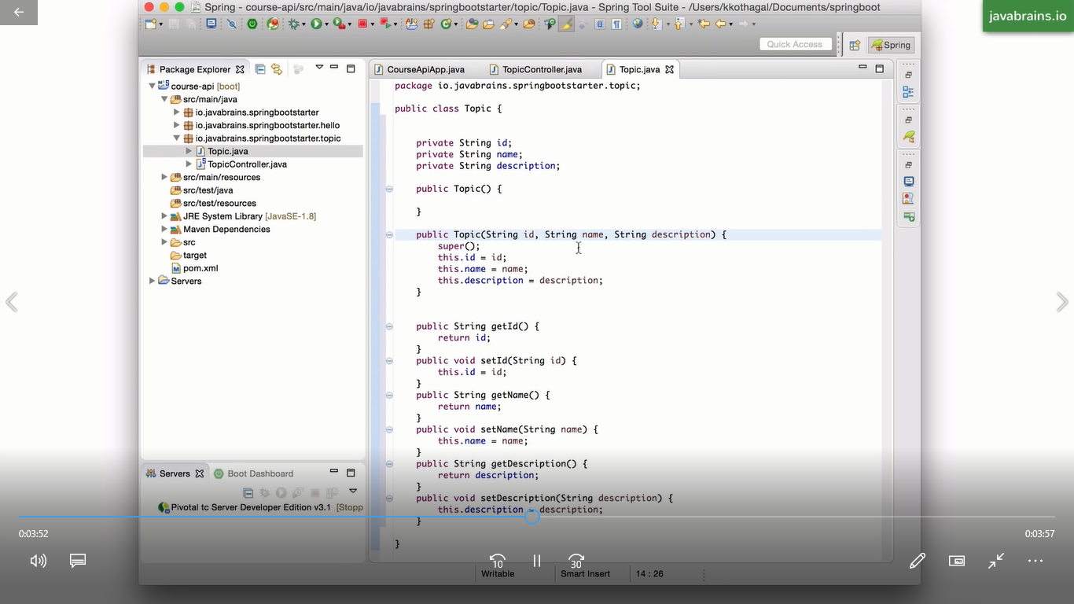

**Spring MVC Controller**

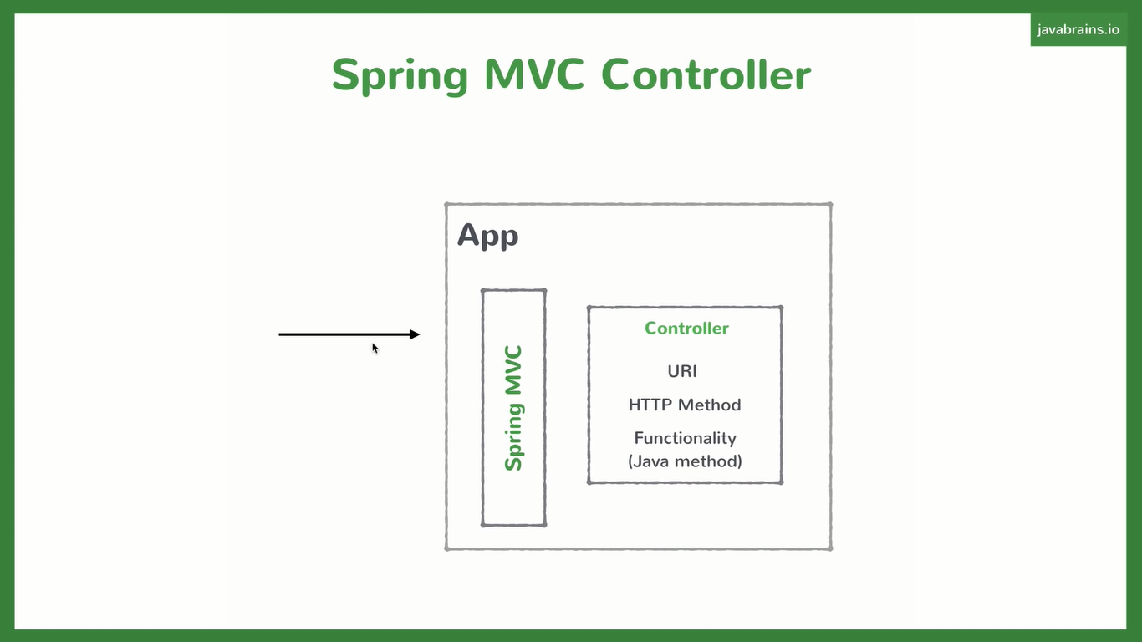

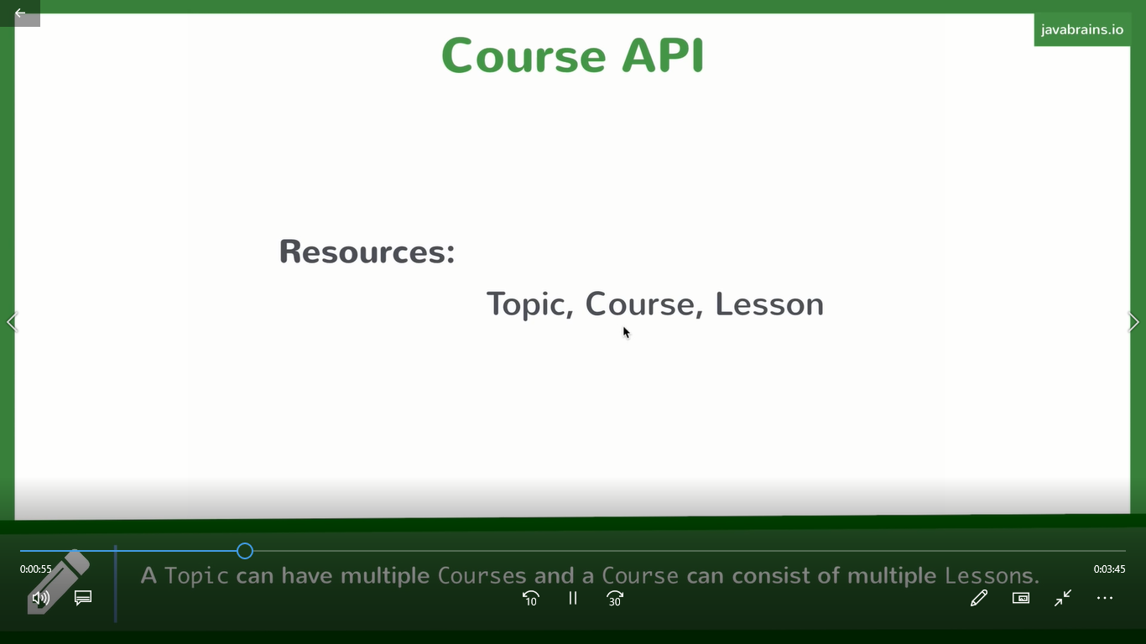

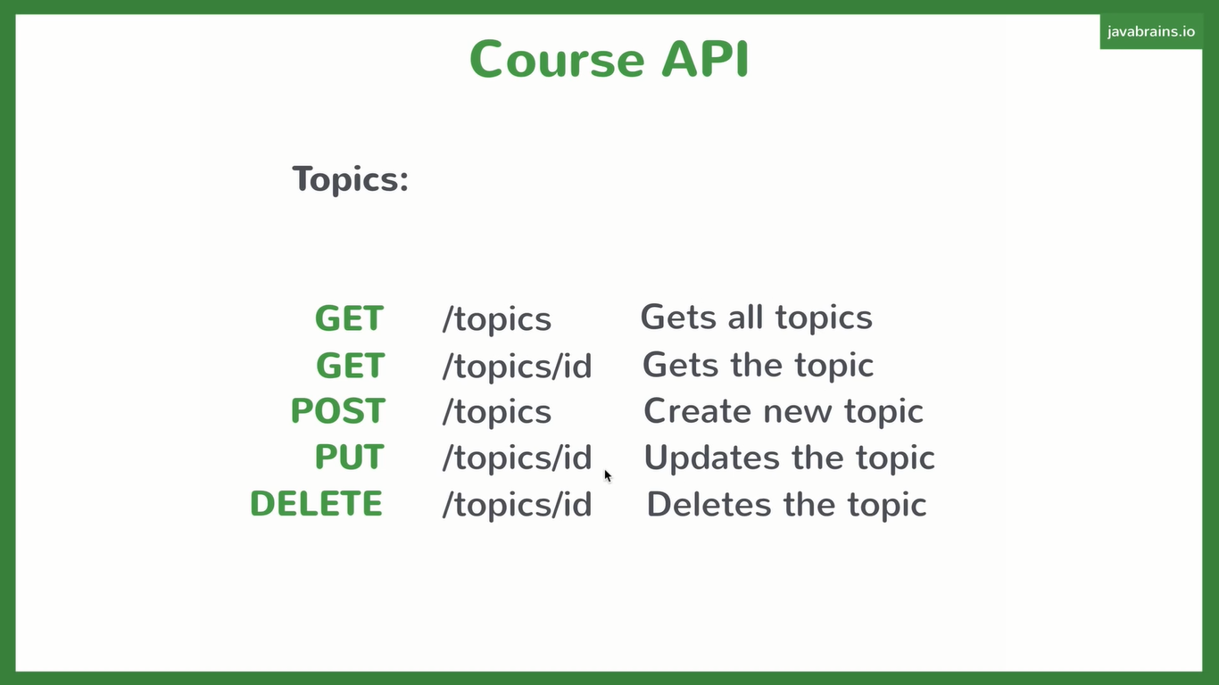

**Creating service class**

It is call Buisness Service .it is typically a singleton class when application is statup spring create an instance of this class Service class providing

Denoted by @Service is a sterotype@.

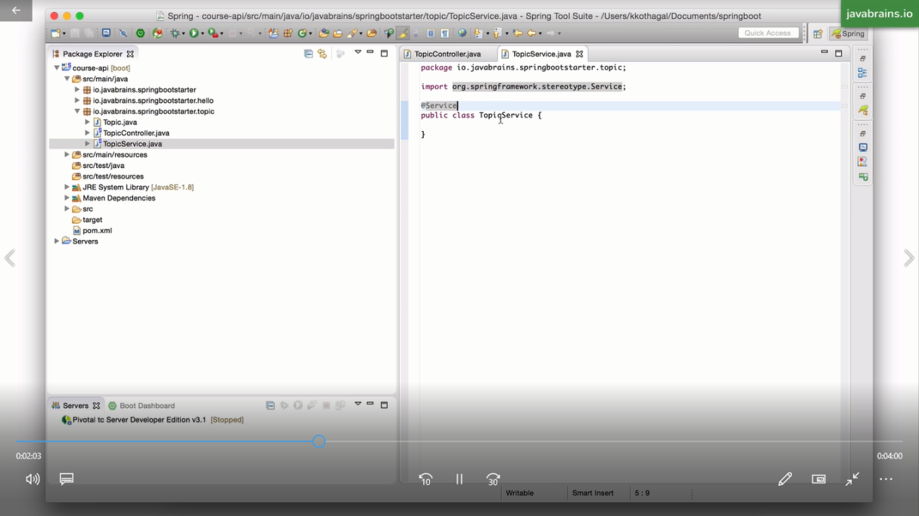

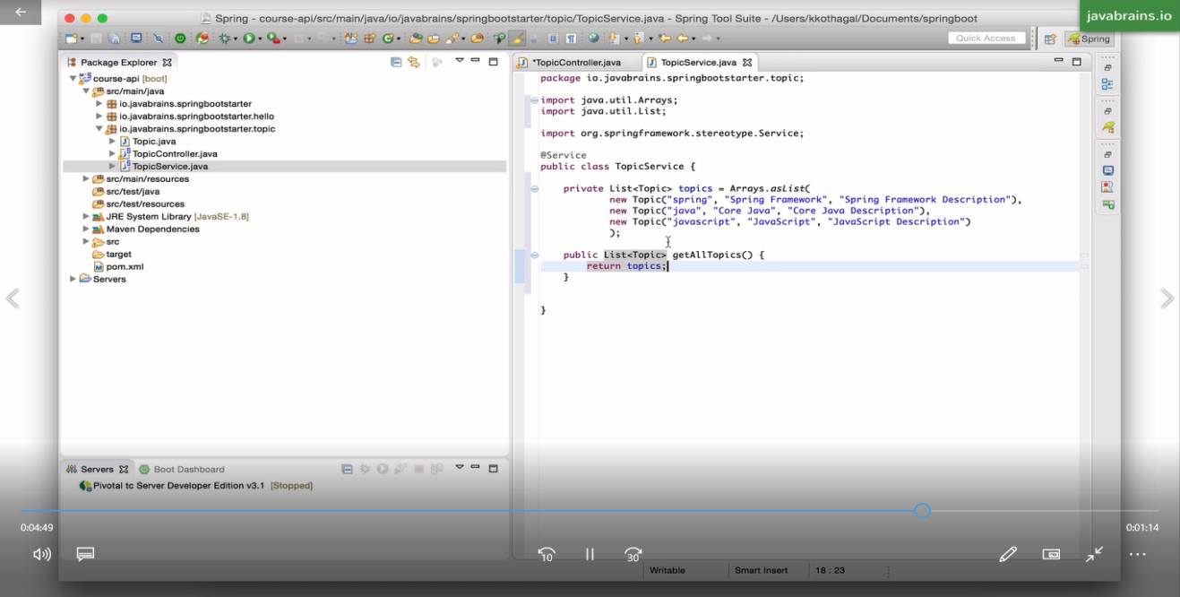

For injectiong this service class in controller class as dependency we are using @Autowired which is perform dependency injection.

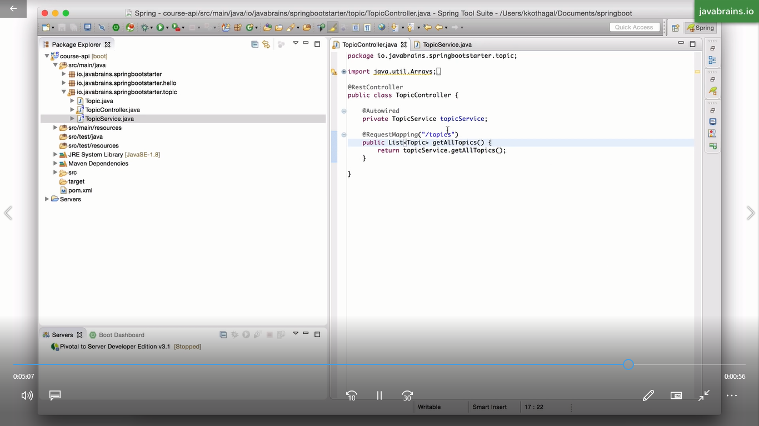

**Getting a single Resource:**

Serviec Class:

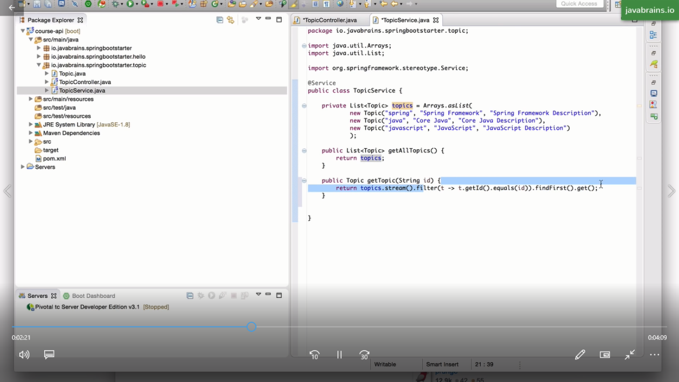

Controller Class:

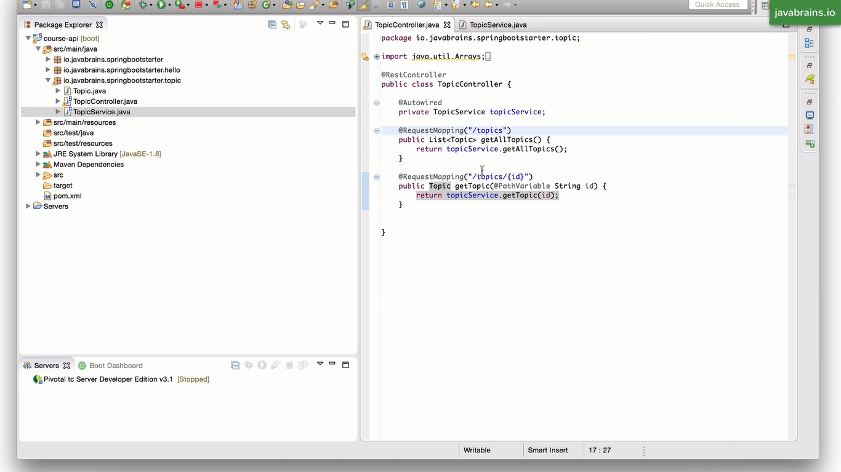

Note: Here @PathVariable scaning the path variable and passing it to service class by id in service class it is matching the list of topic id and return the matched id full data from service layer to controller layer.

**Creating New Resource Using POST Request**

**Controller Class**

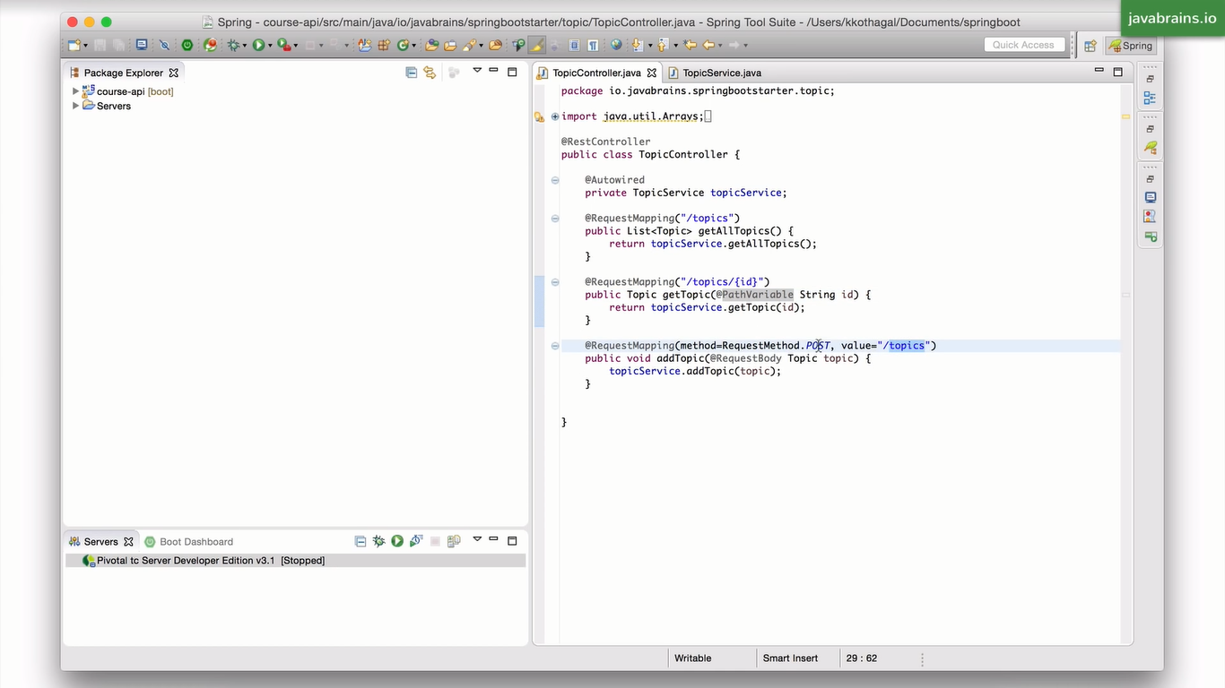

Service Class:

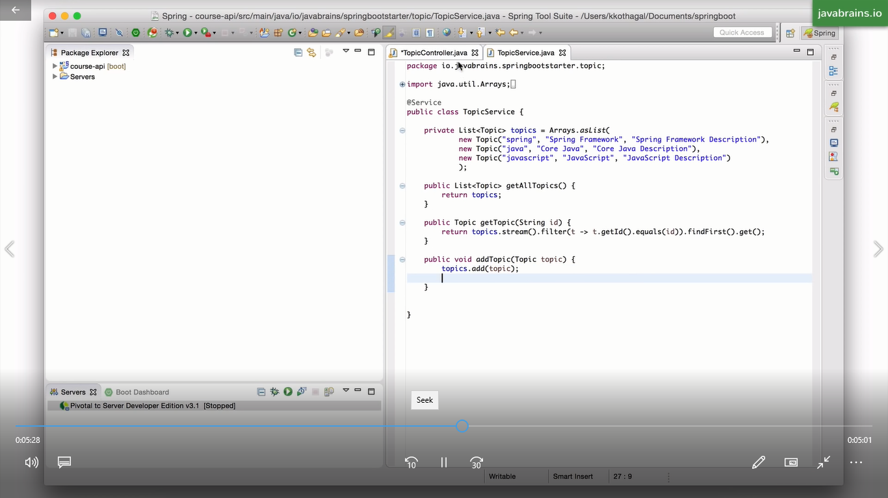

For making this is request we have to make request from post man which is a chrome plugin which we are using for rest api call from where we can post request body with post Request.

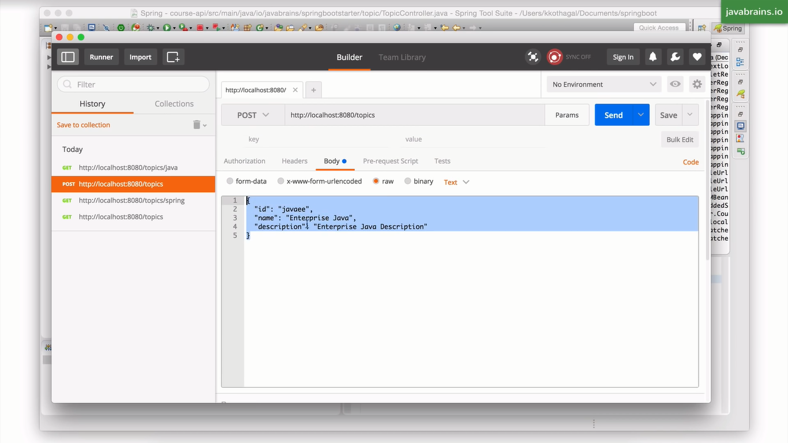

**After Hitting getting error**

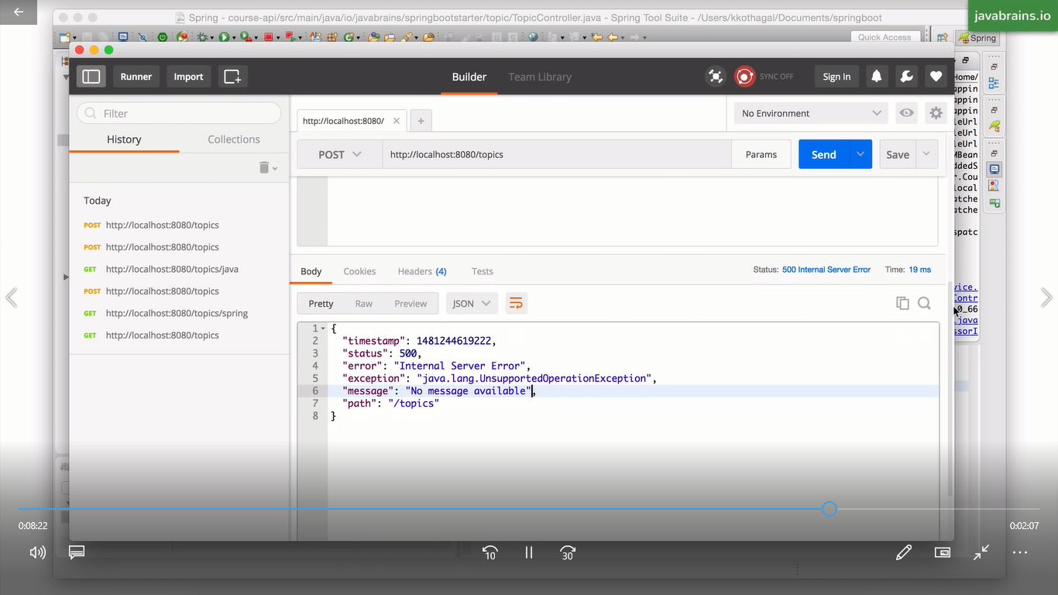

Because ArrayList we make immutable in Array.list method provide immutable list so we are making it Mutable by creating new arraylist so we have to make it mutable by changing code in Restcontroller class which is the following.

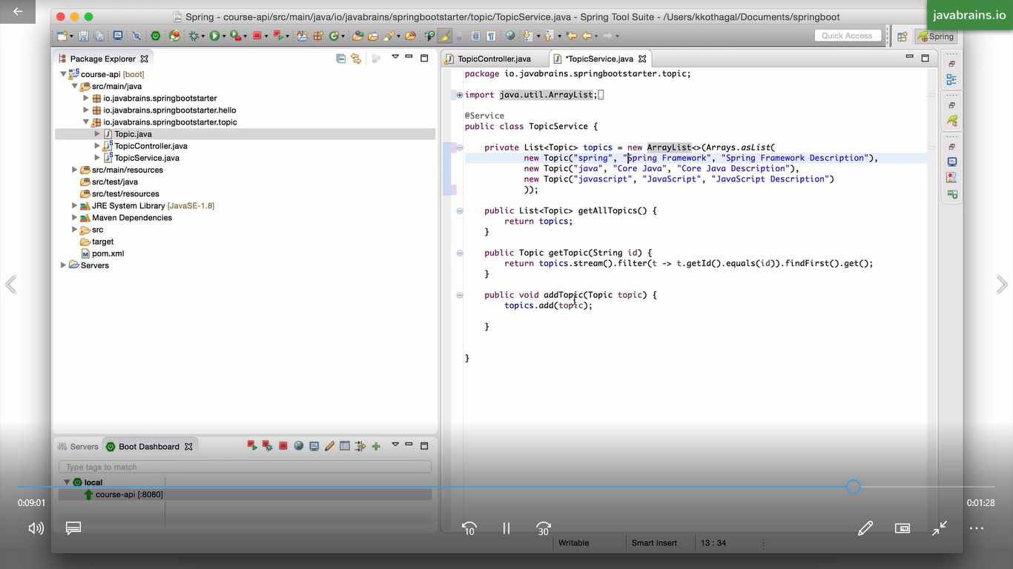

Implementing Update and Delete :

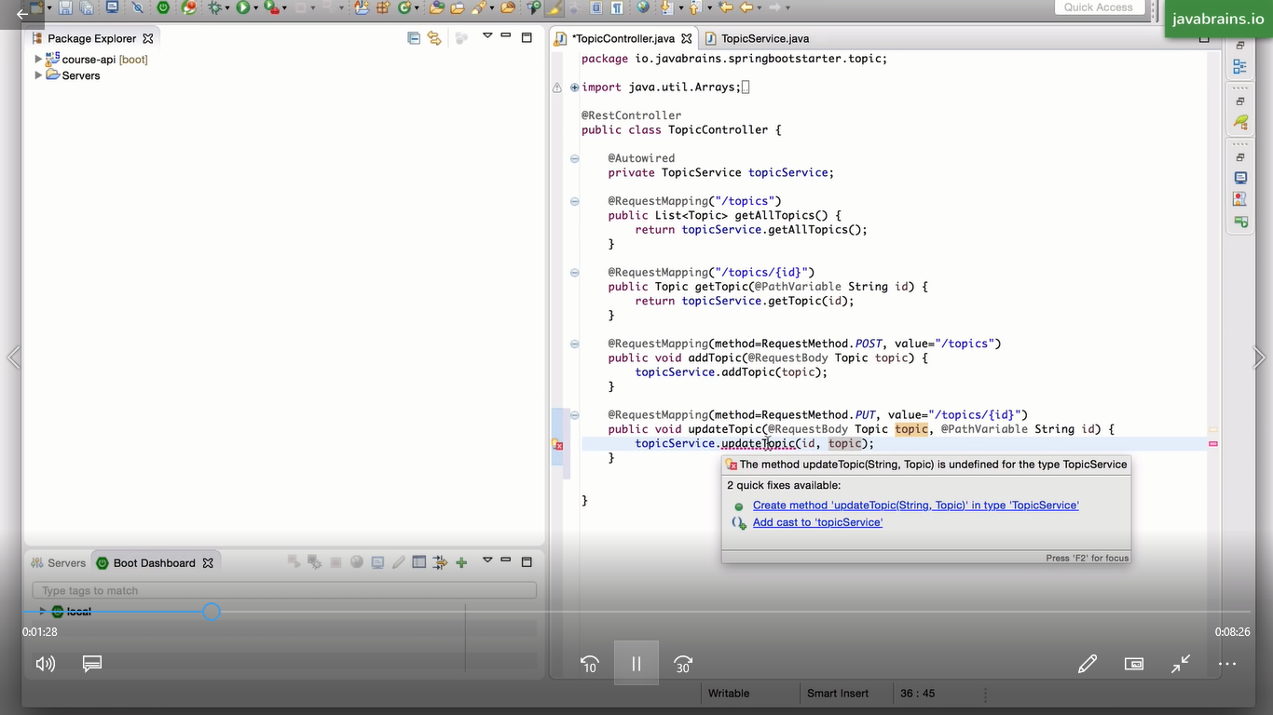

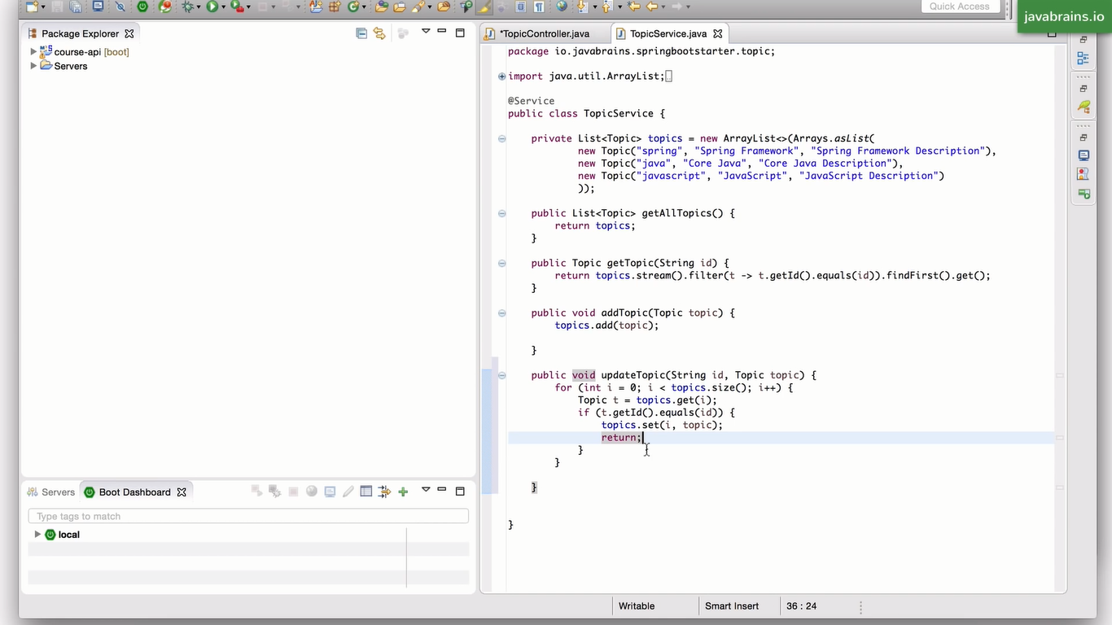

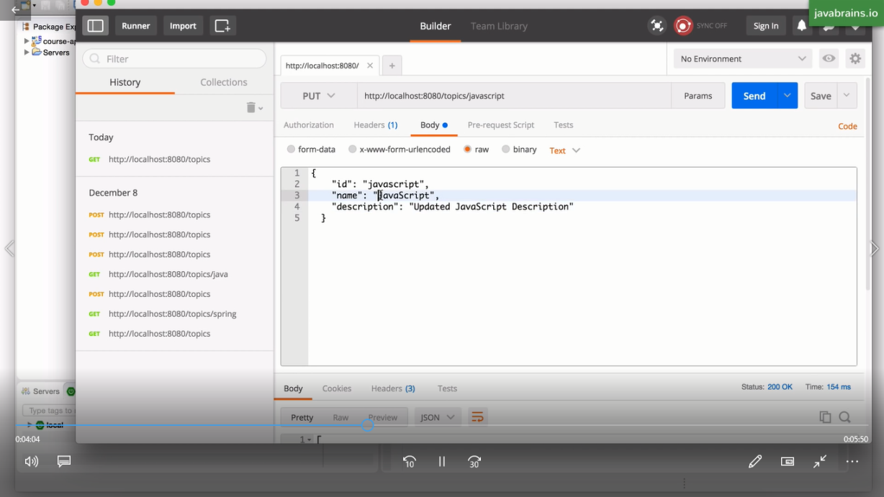

**Making Delete Request:**

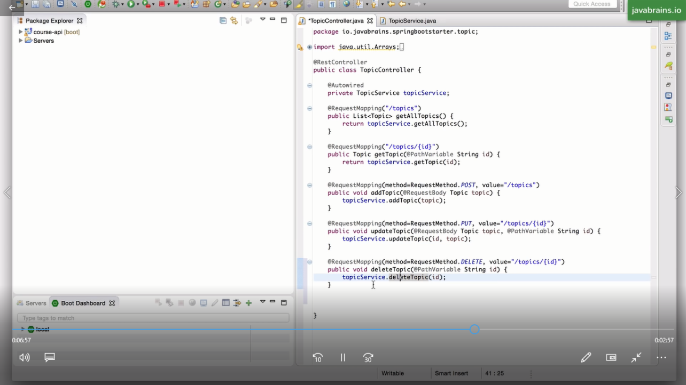

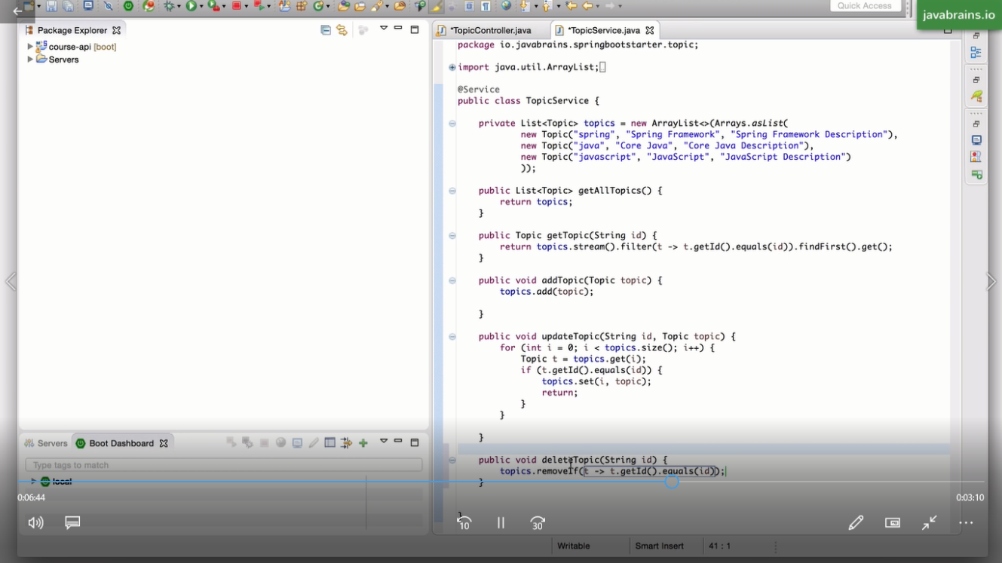

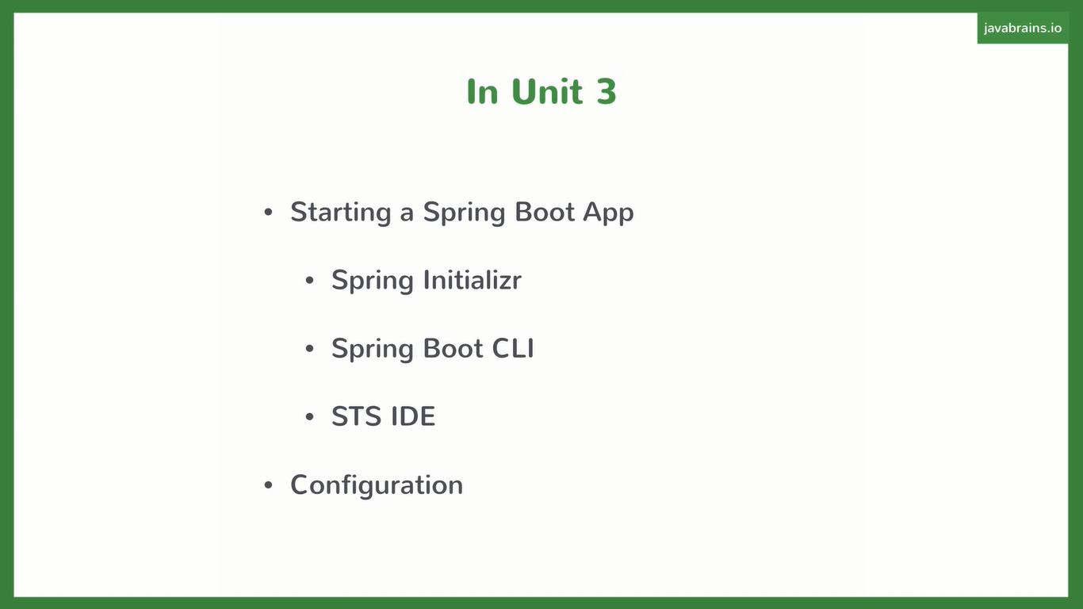

**Spring Boot App Using Spring Initilizer :**

**Available link:**

**http://start.spring.io**

**~~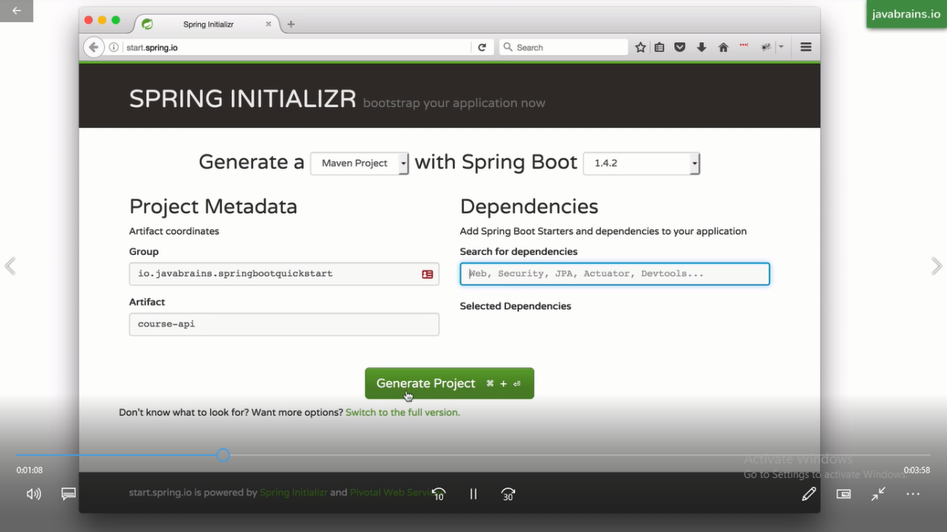~~**

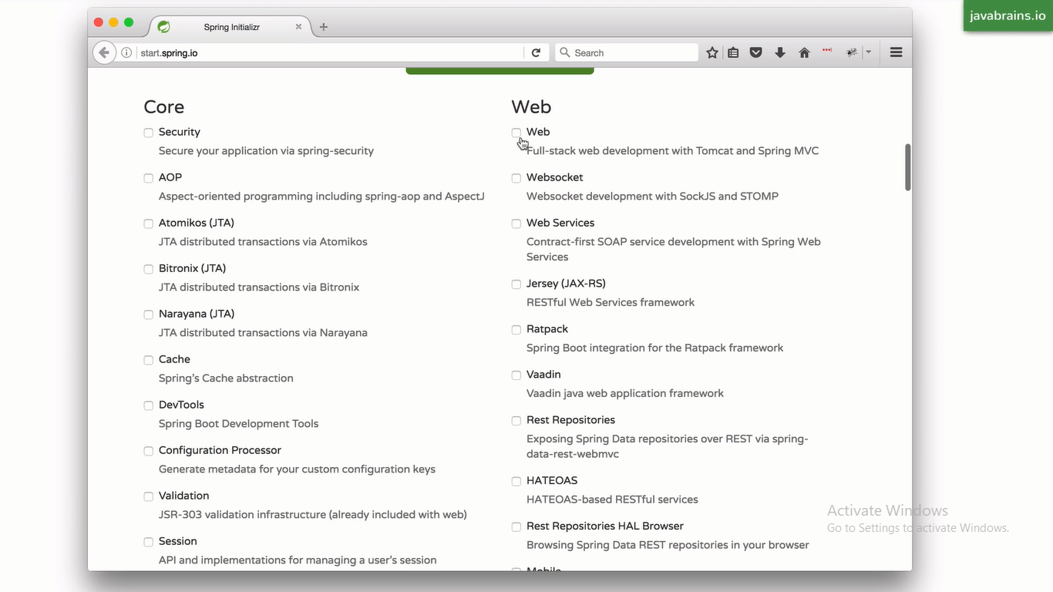

After Setting all Configuration we have to click on generate Project which is asking for Zip file generation and then save into a local directory and unzip it

Then import an existing maven project.

Docs link for Setting custom properties:

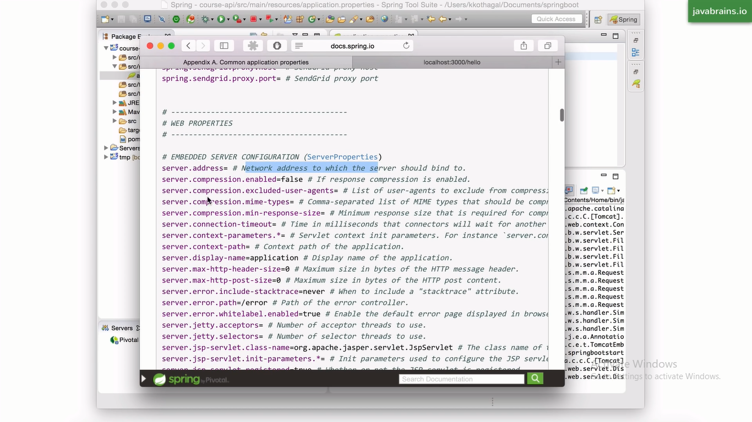

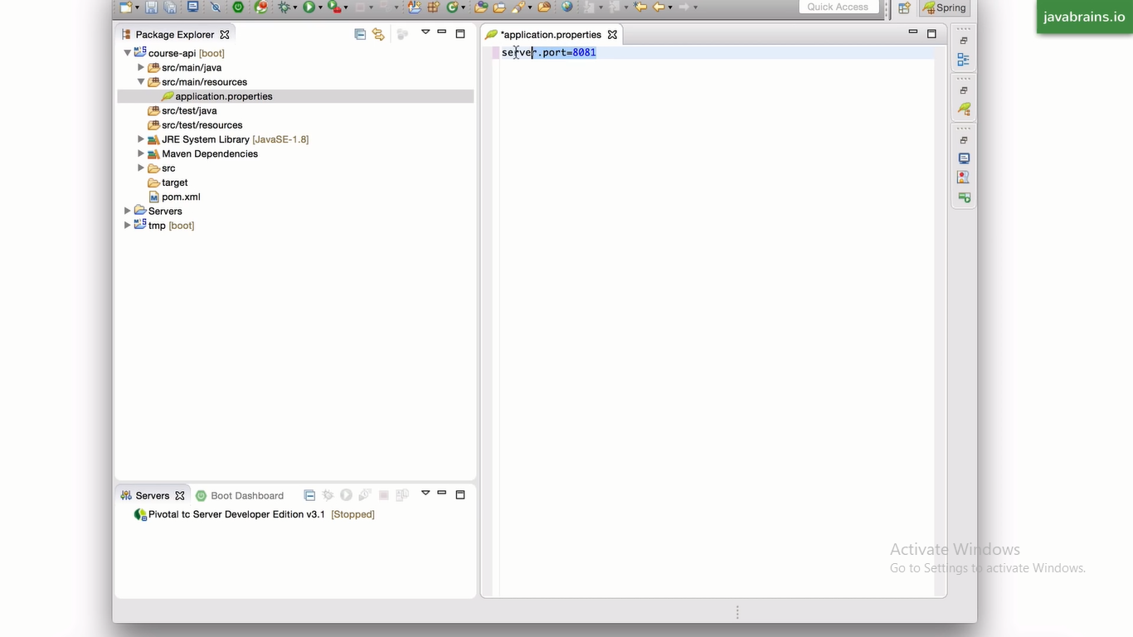

**Spring JPA:**

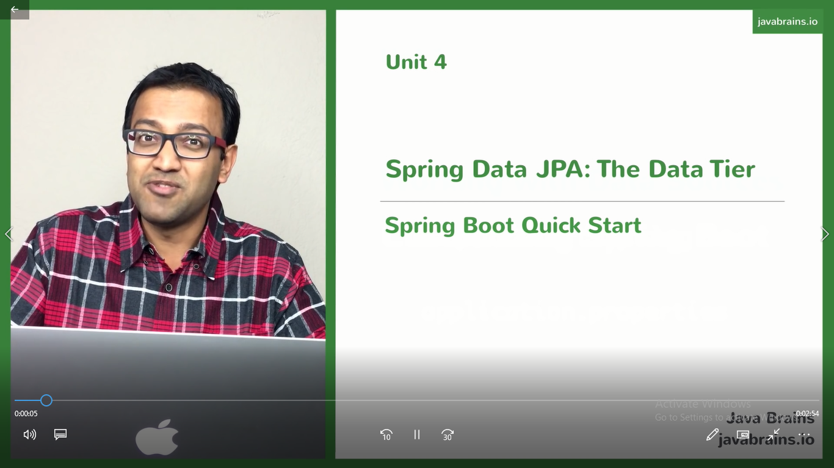

**JPA(Java Persisitence API):**

It Is a Specification which let You do ORM(Object Relational Mapping) when we connecting to Relational database.

Orm let you met our entity classes to database sql table and send meta data with it so we don’t need to write manually query spring framework do for us and jpa provide spce between entity class and db table.

**Creating Course API data Project:**

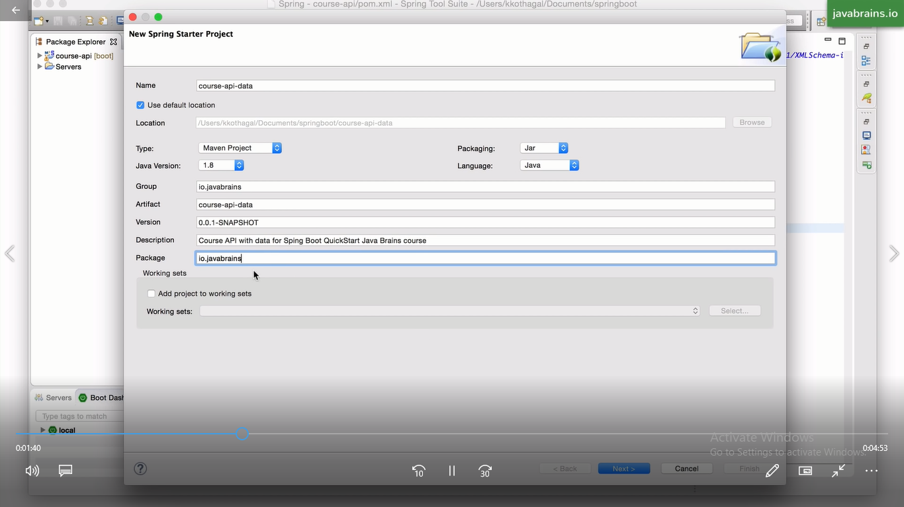

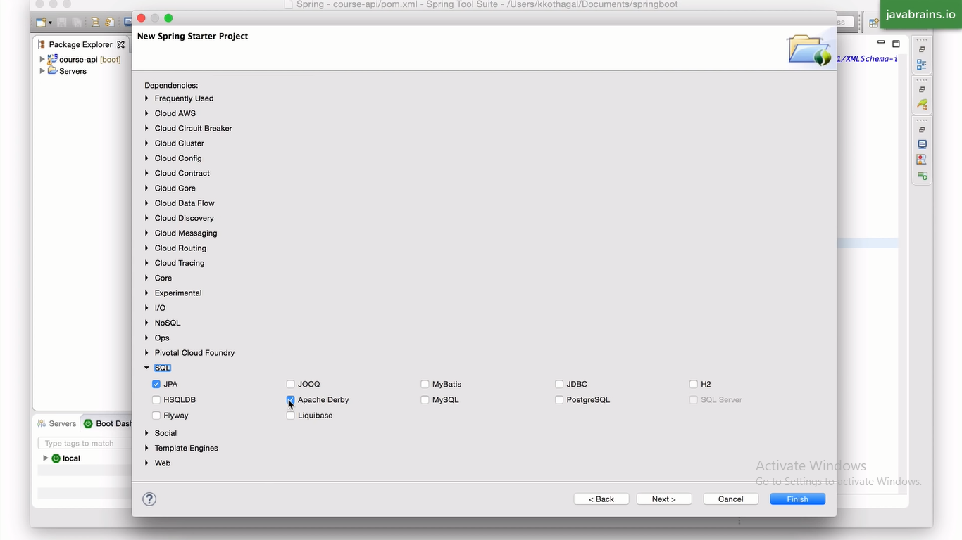

**Pom.xml**

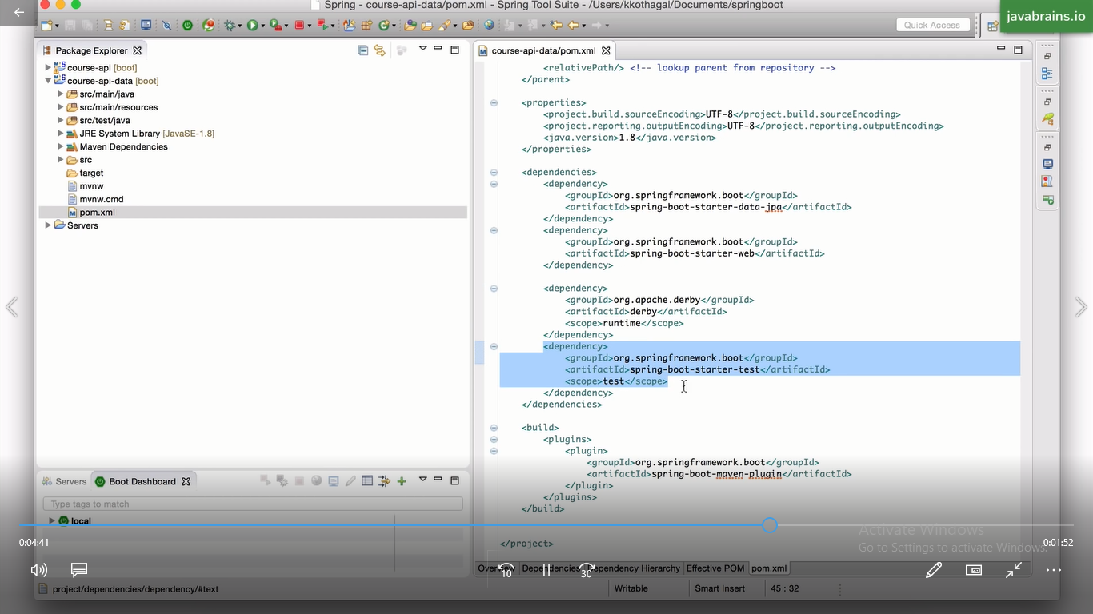

**Directry Structure:**

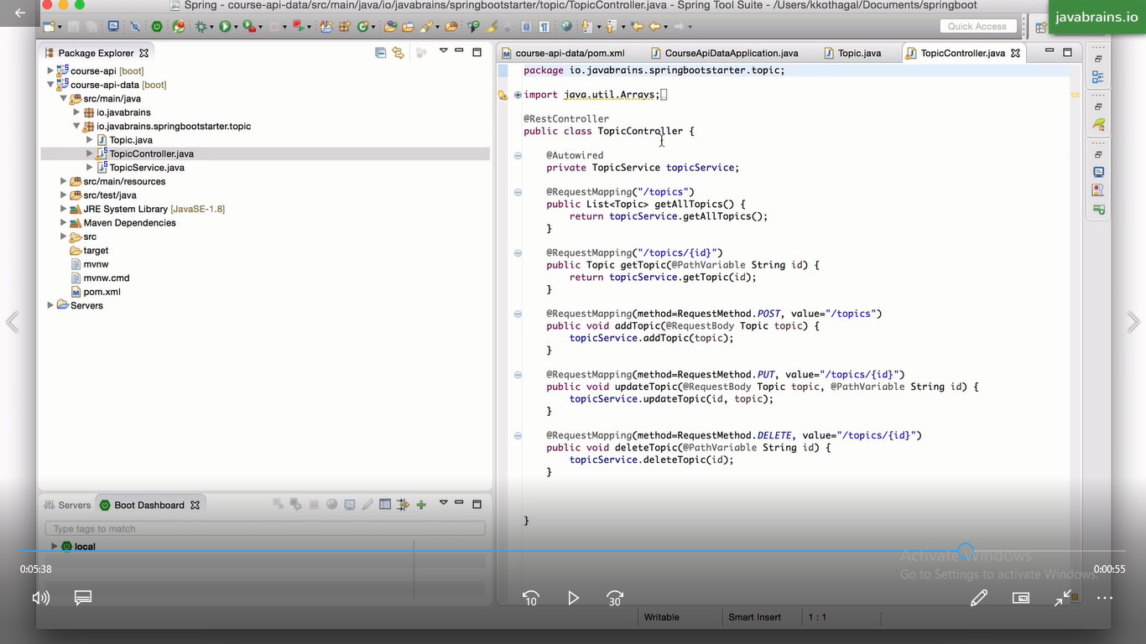

**Dropping io.brains.springbootstarter.topic:**

**Change in model Class:**

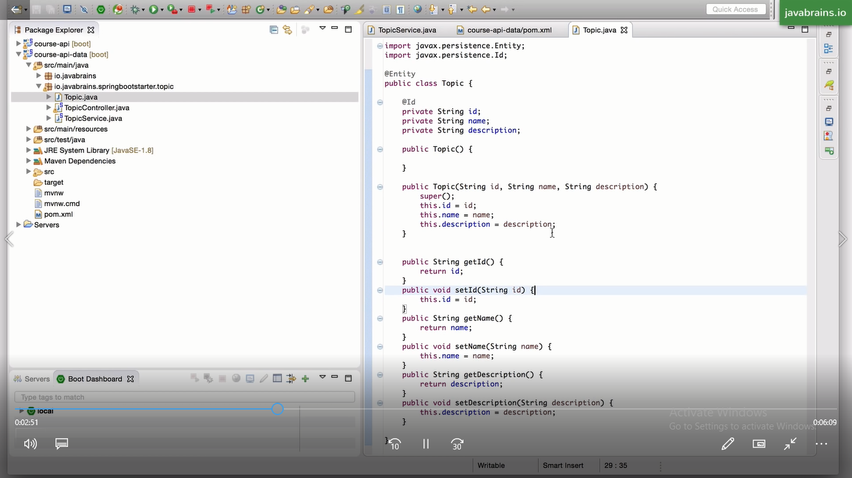

**Create new Class in this package i.e TopicRepository:**

